Strand 4 Antifreeze Gene for Agricultural Crops
The DNA of Arctic flounder contains a gene that produces special antifreeze proteins that allow the fish to survive in cold Arctic waters. Geneticists have been able to isolate this gene and insert it into the DNA of certain agricultural crops.
SC10STSXCC35Q9071359O
a) Explain how the antifreeze gene could be beneficial in growing agricultural crops, such as
tomatoes.

b) Describe two concerns a consumer might have regarding the insertion of animal DNA into
agricultural crops.

Possible Correct Responses:
Benefits:
− It could allow certain varieties of agricultural crops to be grown in colder areas where they were previously unable to be planted.
− It could extend the growing season in cold areas for crops that contain the gene, allowing for a
longer/larger harvest.
-It could reduce crop loss from early or late frosts.
Other acceptable responses

Concerns:
− Some crops may become allergenic.
− The crops may cause unknown health risks.
− The flavor of the crops may be compromised.
− There may be unintended effects on the plants.
− Labeling is not required for GM foods and vegetarians wouldn’t know whether they were consuming a product that includes animal DNA or not.
− Genetic pollution (pollen from GM crops may cross-pollinate non-GM crops and/or organic crops,rendering farmers unable to certify their crops as organic).
− Reduced genetic variation (farmers may opt to plant only the GM varieties to reap the benefits of the new genes).
− Crops may indirectly promote antibiotic resistance. (In transplanting genes, there is need for a
marker to identify which cells have taken up the foreign gene. One way is to attach a gene for
antibiotic resistance.)
− Other acceptable responses
3-Point Rubric:
Score 3
The response explains how the antifreeze gene could be beneficial to certain agricultural crops and describes two concerns a consumer might have regarding the insertion of animal DNA into agricultural crops.
Score 2
The response explains how the antifreeze gene could be beneficial to certain agricultural crops and describes one concern a consumer might have regarding the insertion of animal DNA into agricultural crops.
-or-
The response describes two concerns a consumer might have regarding the insertion of animal DNA into agricultural crops, but fails to explain or incorrectly explains how the antifreeze gene could be beneficial to certain agricultural crops.
Score 1
The response explains how the antifreeze gene could be beneficial to certain agricultural crops, but fails to describe or incorrectly describes concerns a consumer might have regarding the insertion of animal DNA into agricultural crops.
-or-
The response describes one concern a consumer might have regarding the insertion of animal DNA into agricultural crops, but fails to explain or incorrectly explains how the antifreeze gene could be beneficial to certain agricultural crops.
Score 0
The response provides little or no accurate or relevant information related to the tasks.
Response #1 (3)
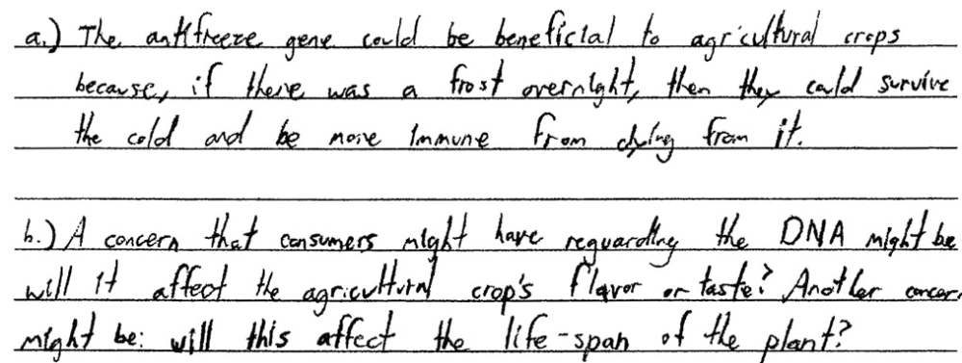

Response #2 (2)
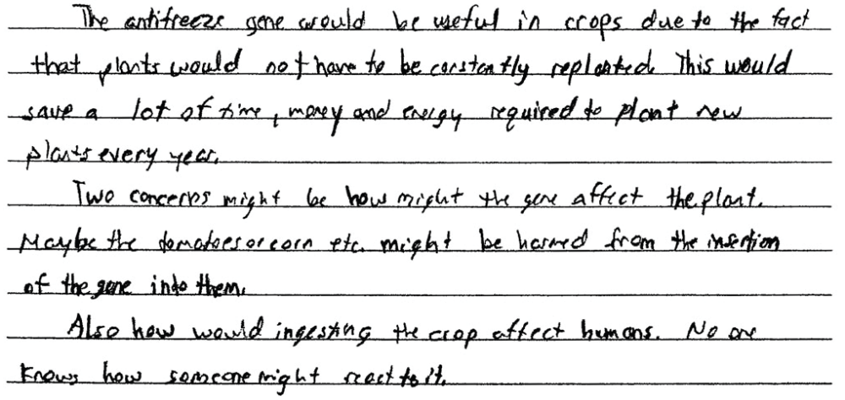
Response #3 (1)
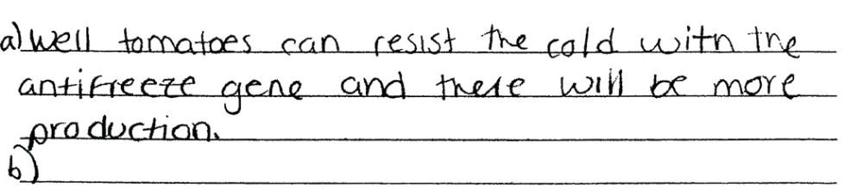

Response #4 (0)
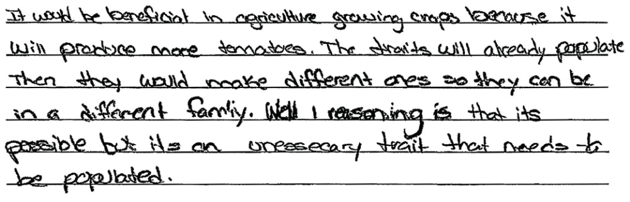
Response #5 (2)
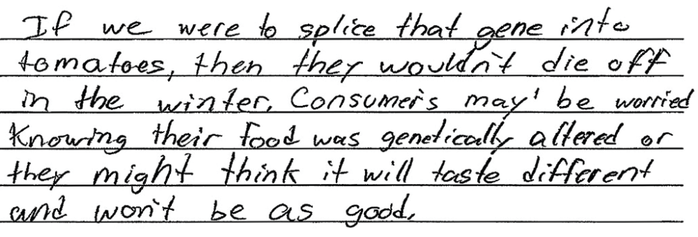
Response #6 (0)


